Precision and Recall
In my previous article i’have tried to explain the confusion matrix using to examples The medical model and Spam classifier model.
As i said previously the medical model is okay with incorrectly diagnosing a healthy patient as sick i.e (False Positives) but it’s not okay when a sick patient is incorrectly diagnosed as healthy i.e (False Negatives).
The Spam classifier model on the other hand is okay with False negatives(When a email is spam model incorrectly send it to inbox) but it’s not okay with Fasle positives (When a email is Not spam model incorrectly send it to spam folder), since we don’t necessarily need to find all the spam emails but one thing is for sure, that if we do label something as spam, it better be spam.
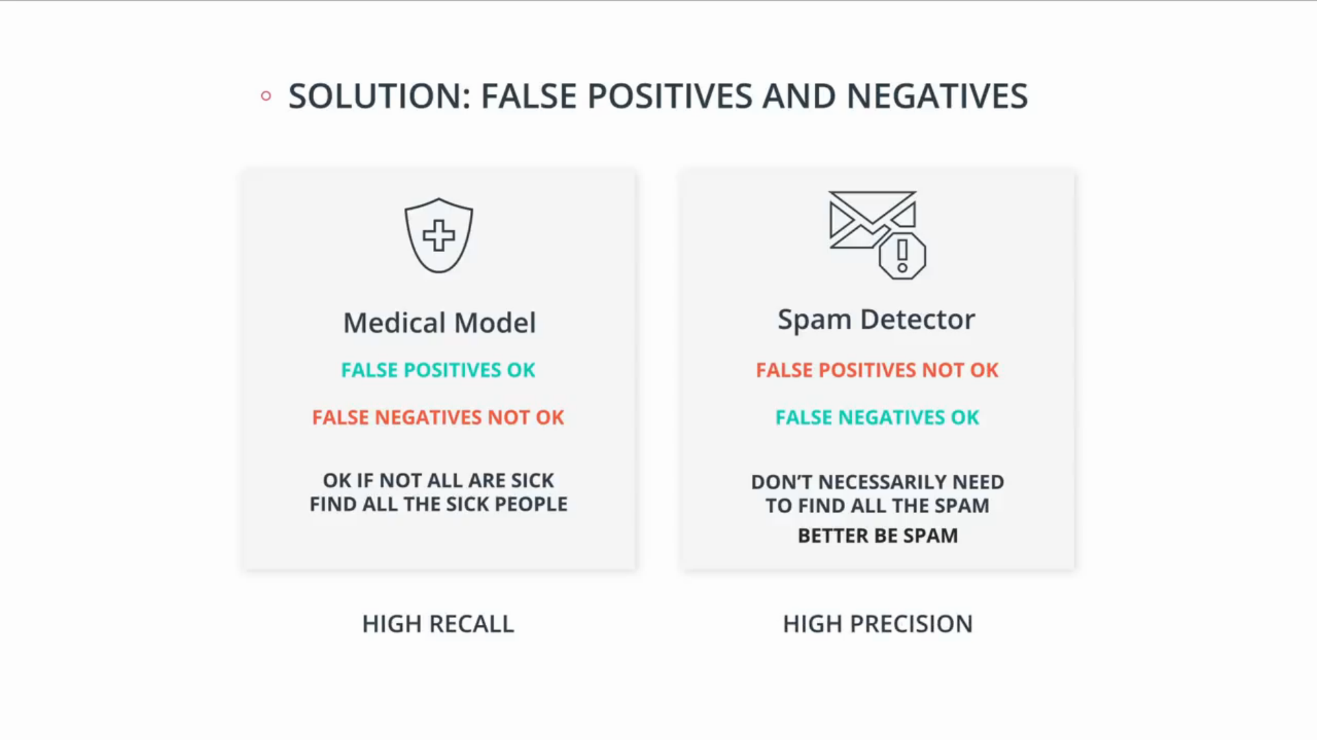
For this, we introduced two metrics, Precision and recall, the medical model needs to high in recall model and the email model needs to be high in precision model.

So let’s define the precision metric as follows, Here is the confusion matrix for the medical model
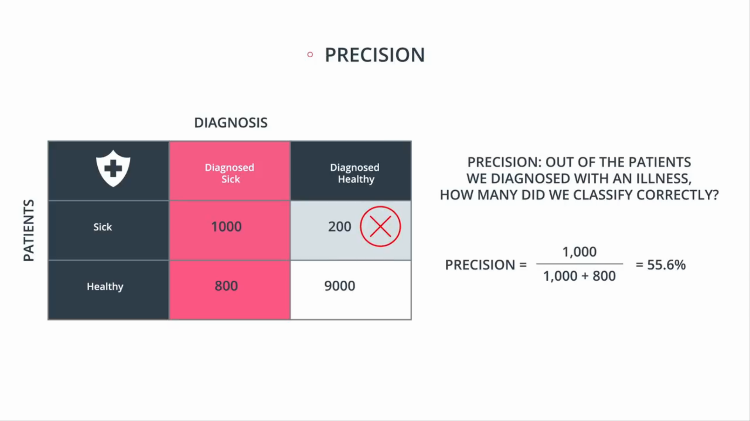
As you can see i’ve added a red x in the spot that we really want to avoid, which is the false negatives. For this model precision will be “Out of the patients we diagnosed as sick, how many were actually sick?” so precision is that red column “Diagnosed Sick” because this column are the sick patients that our medical model diagnosed them as sick.
So it is 1000 that our model correctly classified and 800 misclassified. The precision can be claculated as
Precision = 1000 that we correct / 1800 total number of patients diagnosed as sick.
So we get 55.6% its not a high number because this is not a very precise model. But again, this is okay because what we’re doing is avoiding the red X.

Now let’s look at the spam classifer model.
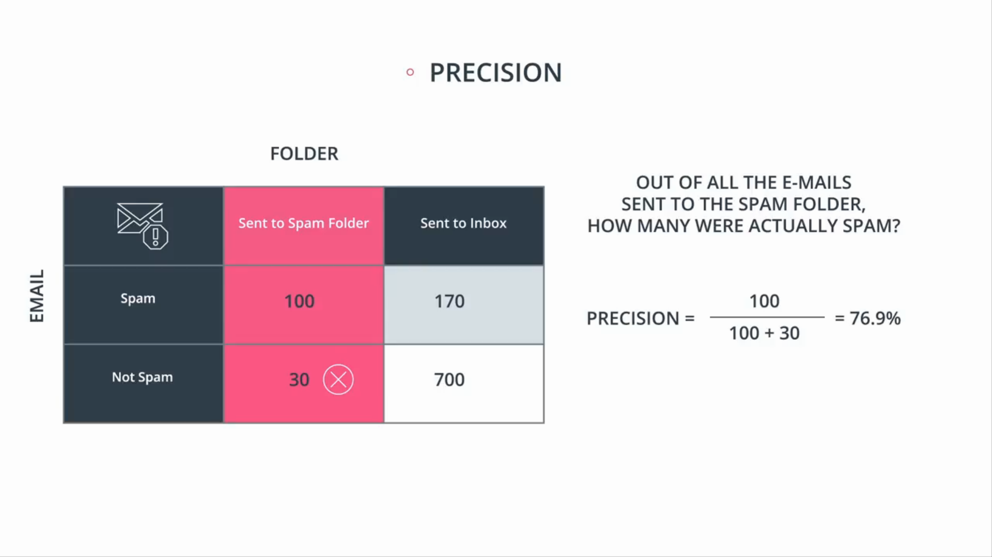
As we can see in this model precision is very important because the red X that we’re avoding is in this column. The red X is the non-spam mail from your Girl Friend that our model accidentally sent to the spam folder
So those 30 errors are really bad and we want to avoid them. So again here, precision is that red column “Sent to spam folder” and precision says “out of all the e-mails sent to the spam folder, how may were actually spam?”.
So precision = 100 which are correct / 130 which is all the one’s we’ve sent to the spam folder.
So we get 76.9%, which is higher, this is better since this model needs high precision so the number better be big.

Recall
Now, let’s see the second metric, which is recall for the medical model.
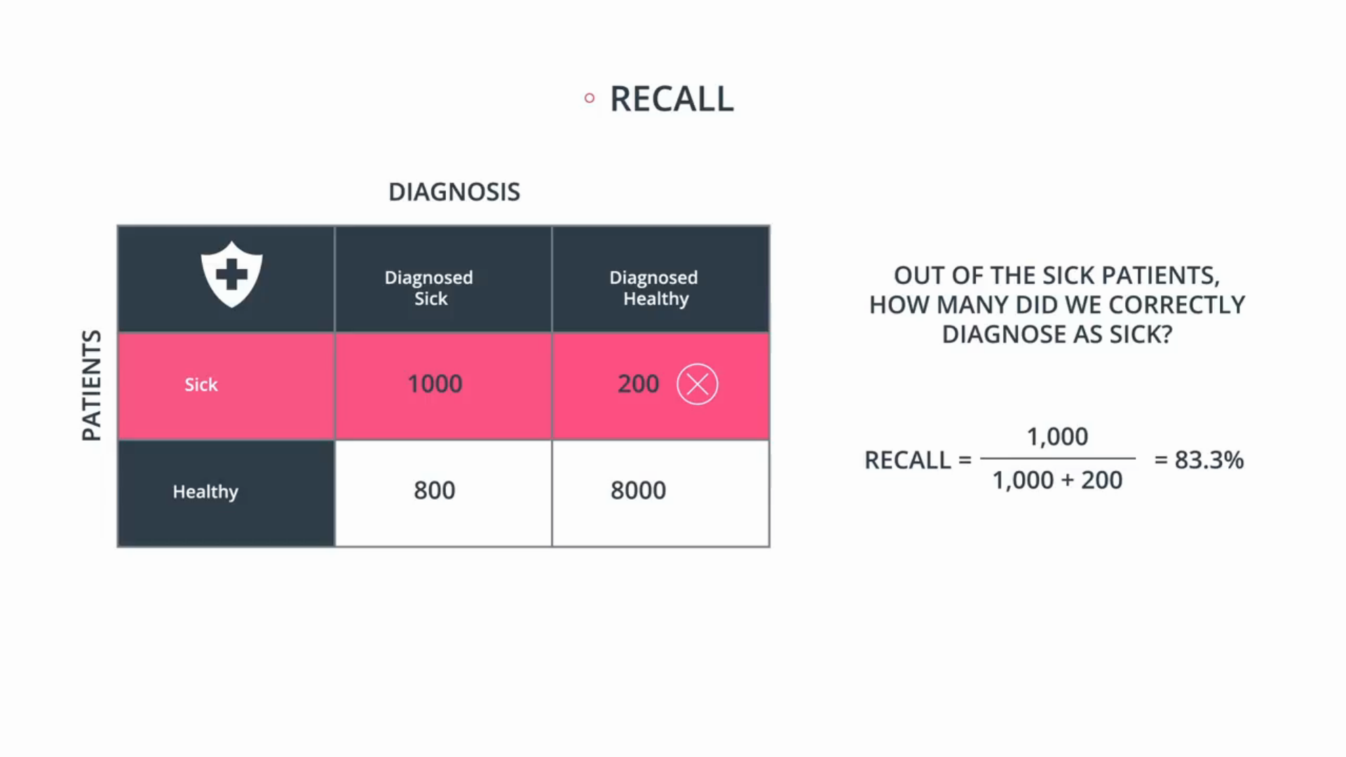
In medical model recall is the answer to the following question “Out of the sick patients, how many did model correctly diagnose as sick?” So remember precision was “Out of the patients were diagnosed as sick how many were actually sick?” but recall is the opposite.
As we can see red X is in the red column so recall is important in the medical model. Now to calculate recall, we do the following,
from the 1200 sick patients how many did we diagnose correctly?
Recall = 1000 which are correct / 1200.
which is 83.3% this mdoel better have a higher recall because we’re trying to correctly catch as many of the sick people as possible.

Now Spam email classifier model
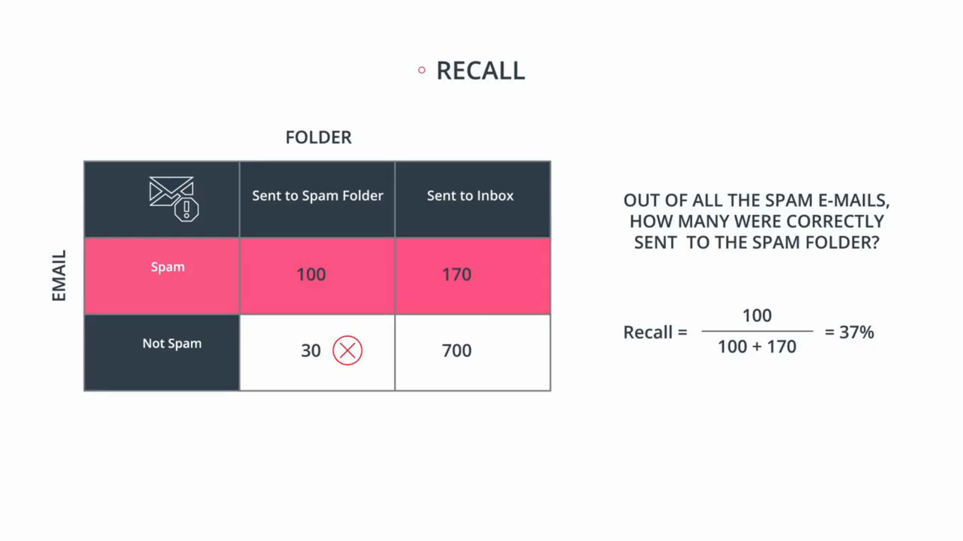
The recall is defined similarly.
Its calculated as follows, “from the spam emails how many of them do the model correctly send to the spam floder?“
So the answer is in that red row over there,
Recall = 100 correctly sent to the spam folder / 270 total spam emails.
Its low number 37% . But remember we are worried about avoiding this X over here, since we don’t mind if we don’t catch all the spam emails as long as the ones we caught are spam.
So it’s okay that this model has a low recall.

Now you have seen our medical model has a precision of 55.6% and a recall of 83.3%. Its supposed to be high recall model. And our spam detector has a precision of 76.9% and a recall of 37% and is supposed to be a high precision model.

Now the question is do we want to be carrying two numbers around all the time? Like carrying precision in one pocket and recall in other one. Well this is inconvenient we kind of want to only have one score.
So the question is, how do we combine these two scores into one? Can you think of a way?. Well i give you the simple way to do this in upcomming Article.

